LIVE VIDEOS IN WORD
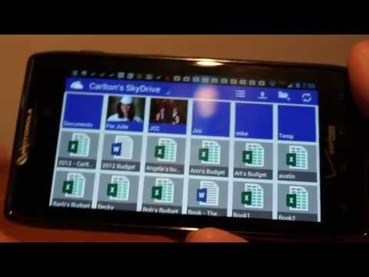
Q. I am in the process of updating an older Word 2003 document containing videos (inserted as embedded objects). Previously in Word 2003, the video appeared as a video window, and when double-clicked these videos played in place within Word 2003. However, in Word 2013 inserted videos appear as a file icon and when double-clicked, Word launches the Windows video player and then plays the video separately from my Word document? I like the old way better; is there a way to make embedded videos play from within Word like they used to?

A. I like the older Word 2003 method better too, but when Microsoft redesigned Office 2007, they changed the video playback method to provide more video controls which are available via the Windows video player. The good news is that in Word 2013, Microsoft has brought back this older functionality to a degree by allowing the video to play in a floating player atop the Word 2013 document.

